  - St Joseph’s Primary Hopetoun

OHS Induction
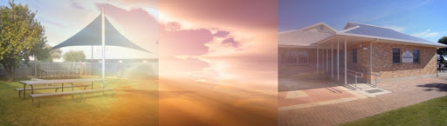
3 Lascelles Street
Hopetoun VIC 3396
Phone: (03) 5083 3296
E-Mail: principalo@sjhopetoun.catholic.edu.au Web: www.sjhopetoun.catholic.edu.au

Contents
Contractor Management 2
Access to Work Site and Signing In 4
COVID 19 Safe Work Arrangement: 4
Contractor Approval: 4
Traffic Management and School Times 5
Safe Work Method Statements / Job Safety Analysis: 5
Working Alone / Isolated Works 6
Emergency Management 7
Utilities and Building Services 8
First Aid 9
Restricted Areas/Toilets 9
Vehicles and Equipment 10
Work Time Restrictions 10
Polices of St Joseph’s Primary School 10
Bullying and Harassment 11
Hazards 11
Asbestos Management 11
Confined Space Entry 13
Personal Protective Equipment (PPE) 13
Plant & Equipment Safety 13
Worksite Security 14
House Keeping 14
Completion of Work/s 14
Incident & Injury Reporting 14
Termination of Services 15
Contractor Safety Management Checklist 16
School Safeguarding Children and Young people: 19
Code of Conduct 19

Contractor Management
St Joseph’s Primary School is committed to providing a safe, healthy and secure environment for all members of its school community including contractors engaged to undertake work on the school’s behalf. To ensure the quality & safety of the services provided by contractors & their employees, St Joseph’s Primary School will ensure that only those qualified or suitably experienced, with comprehensive risk management systems, licences and insurances will be considered to provide services.

A copy of the company’s current Public Liability Insurance certificate – (Mandatory)
- A copy of the company’s Work Cover certificate (Mandatory)
- Relevant licences/qualifications (Mandatory)
- Working With Children Check (Mandatory)
- Risk Assessment (SWMS (Safe Work Method Statement) – JSA(Job Safety Analysis)) (Mandatory)
- Safety Management System (where applicable)
Contractors are required to provide Safe Work Methods Statement or a Job Safety Analysis prior to commencing work at St Joseph’s Hopetoun

Child Safety at St Joseph’s Hopetoun
All students & young people attending St Joseph’s Primary School have the right to feel safe. The school affirms its commitment to child safety by adopting a ‘zero tolerance’ to child abuse and by actively implementing and managing strategies to help protect children from harm.
All contractors and their employees will be screened to ensure they do not pose a risk to students or other members of the school community prior to being authorised to commence work. Contractors & their employees must maintain a current Working With Children’s Check (within 5 years of issue) at all times. Copies of WWCC must be provided to the school prior to commencing work. Where a WWCC has not been provided the contractor or their employee will not be permitted to conduct work in the presence of any student. Where this occurs and the work is of an essential nature (ie… emergency) arrangements may be made to ensure that a Staff Member is present at all times.
All contractors & their employees will be required to complete the School’s Child Safety Code of Conduct training course ‘on-line’ prior to being authorised to conduct work on its behalf or will be provided with a copy to read and sign upon arrival.
The school’s Child Safety Code of Conduct clearly outlines workplace expectations including expected boundaries, acceptable & unacceptable behaviours. Compliance with the behaviours outlined in the Code of Conduct is mandatory, failure to comply with these requirements will result in the termination of services.

Access to Work Site and Signing In
All contractors & their employees must attend the school’s Administration Office prior to being permitted to entering the school site further. All contractors & their employees will be required to sign in and out via the school Attendance iPad.
Where required to attend the school site, after hours ie… weekend/holiday works or in the case of emergency, the Contractor is responsible for informing the Principal or the Business Manager of their entry & exit times. They are also required to establish a ‘buddy system’ when working in isolation.

COVID 19 Safe Work Arrangement:
Contractors & their employees are not permitted to attend St Joseph’s Primary School if they feel unwell in anyway. School Reception Staff will enquire into the immediate health of contractors & their employees and they will be required to complete the school’s COVID 19 Declaration Form prior to being authorised to enter the school.

All contractors & their employees will be provided with a copy of the school’s COVID Safe Plan and required to follow all safe work arrangements outlined in this document at all times. Contractors who employ more than five workers are required to maintain a COVID 19 Safe Plan in accordance with Department of Health & Human Service requirements. A copy of this plan must be provided to the school prior to any work commencing.
Any contractor or their employee who displays any of the following symptoms or who lives at an address where someone has experienced these symptoms within 14 days of their intended school site visit, will not be permitted entry:
- Flu like Symptoms
- Fever
- Coughing
- Shortness of Breath

Contractors are required, under current OHS COVID-19 Regulations, to report any confirmed diagnosis of Coronavirus (COVID-19) received by them or their employees to Worksafe immediately. It is also expected that the school would be informed of this diagnosis if the employees have recently attended the school site.

Contractor Approval:
St Joseph’s Primary School has developed this Contractor Management Procedure to ensure that anyone engaged to undertake work on behalf of the school is suitably qualified, does not pose a risk to themselves, staff or students and has adequately assessed risks associated with the work they are to undertake.
To achieve this all contractors and their employees must be able to demonstrate they:
- Are suitably qualified and experienced to perform tasks,
- Possess all necessary Licences, Permits, Registrations and Insurance to perform the works safely and in compliance with the appropriate regulations,
- Provide copies of the above mentioned documents to St Joseph’s Primary School before commencing works,
- Have completed the school’s Contractor OHS Induction & Child Safety Standard Code of Conduct via the school’s ‘on-line’ management portal,
- Understand and will comply with requirements of the School’s Child Safety Standards,
- Carry out all works in a manner that does not place themselves or anyone else at risk of injury,
- Employ systems of work that are safe and in which there has been adequate instruction, training and supervision,
- Can operate plant & equipment safely & that all equipment is appropriately ‘tagged & tested’,
- Have been notified of any potential hazards associated with the location or use of the area where the works are to be carried out,
- Completed Risk Assessments - Safe Work Method Statements (SWMS) for the tasks that they are engaged to complete.
A list of all approved contractors is maintained in the School’s Training, Document & Record Management Portal with the currency of all contractor management requirements regularly monitored.

Traffic Management and School Times
The hours of school at St Joseph’s Primary School Hopetoun are as follows:
- Arrival – 8.15 to 9.00am
- Departure 3.10 – 3.30pm
Students leave from the following areas:
- The gate in Lascelles Street – Front Office (Administration)
- The rear gate situated in Toole Street
- The bus lane in Conran Street

Safe Work Method Statements / Job Safety Analysis:
In accordance with the Victorian Occupational Health & Safety Act 2004 & the Victorian Occupational Health & Safety Regulation 2017, Safe Work Method Statements (SWMS) or Job Safety Analysis (JSA) will be required for all work activities undertaken on the school site.
Safe Work Method Statements & Job Safety Analysis:
- Outline a safe method of work for a specific activity,
- Identify hazards and risks associated with completing works,
- Provide appropriate measures to control hazards and risks,
- Assign a responsibility for implementing the controls,
- Organise work, materials and employees.
All contractors & their employees must acknowledge, via signature on the SWMS or JSA, their understanding of the agreed safe work practices and must comply with these safe work arrangements at all times.
Any Contractor or their employees found to breach SWMS or JSA requirements without good reason will be stood down.

Working Alone / Isolated Works
Where a Contractor or any of their employees are required to work in isolation or alone, they are required to establish and maintain communication with either the Principal or their nominee or a work colleague.
Definitions:
'Working alone': is working anywhere a person is unable to get immediate assistance from colleagues or other people.
‘Working in isolation’: is where a Worker is required to conduct work away from other Workers due to time, location or nature of the work.
Examples of Working Alone or in Isolation:
- A contractor working late at night or on weekends at a school premises.
- A grounds person or contractor conducting work after hours, over the weekend or during school holidays.
- A contractor working within a roof space or in the basement of a building.
To ensure the safety of all contractors the following Safe Work Arrangements must be implemented when required to Work Alone or in Isolation:
- Contact must be made with the Principal or their nominee prior to entering & upon exiting the site.
- A reliable communication system must be maintained at all times (mobile phone etc..).
- A ‘Buddy System’ must be established where regular contact (at least every 2 hours) is made with a nominated individual whilst on the school site. This may be with the Principal or their nominee or a colleague.
- A list of emergency contact numbers including emergency services must be easily accessible at all times.
- Ease of access by Emergency Services must be considered with arrangements listed on any Safe Work Method Statements created for the task.
In the event that the whereabouts of a contractor or their employee cannot be verified whilst on the school site, the Principal or their nominee will enact the Emergency Response Procedure.
Contractors or their employees who fail to inform the Principal or their nominee of their attendance at a school site, or who fail to maintain regular communication will be stood down and may have their services terminated.

Emergency Management
Evacuation points as per map.
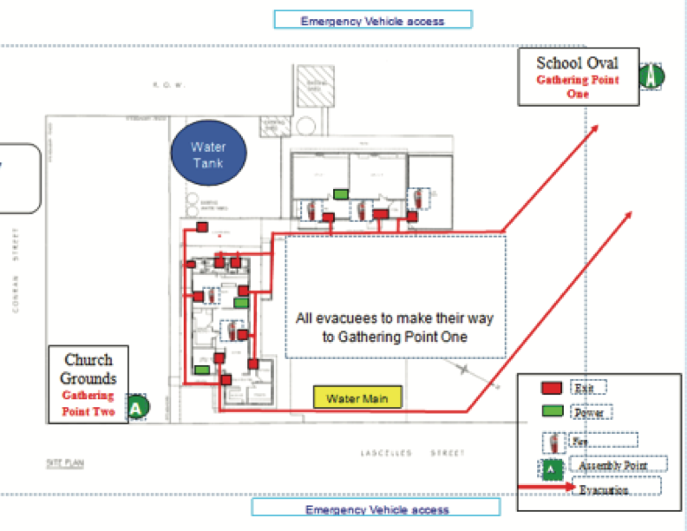

Utilities and Building Services
TYPE | CONTROL / ACCESS POINT | NOTES / SHUTOFF INSTRUCTIONS
Gas / Propane | Nil | Nil
Water | 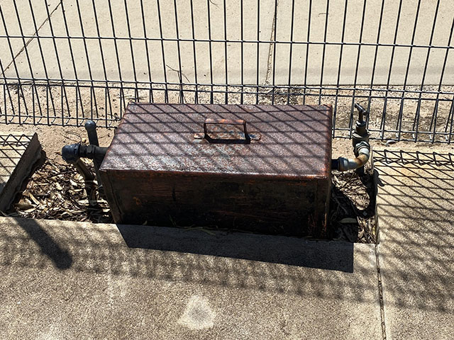  Lascelles Street end of the basketball court | Turn Valve to off
Electricity | Lascelles Street side of the Administration building, near the church.  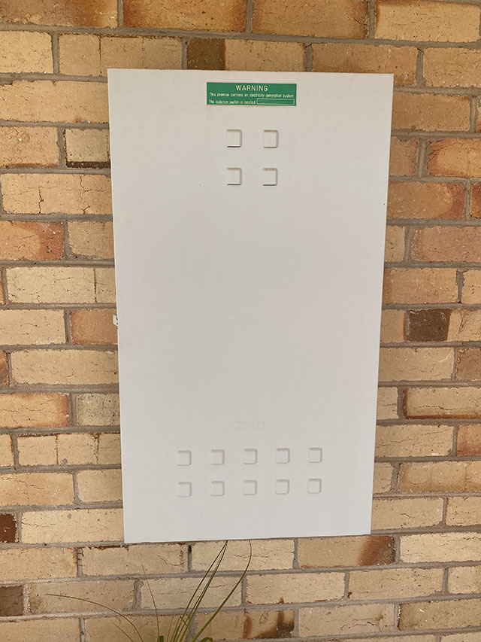  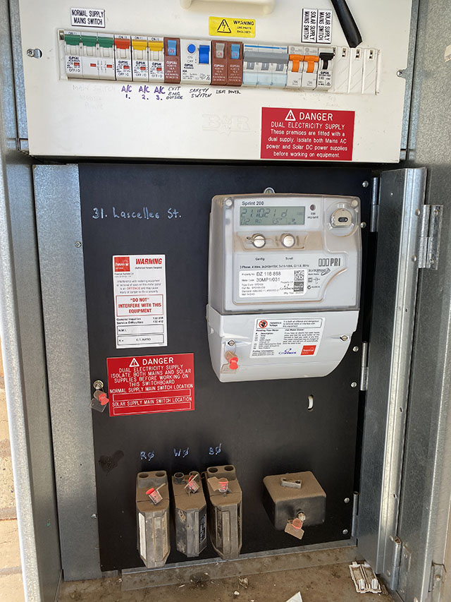 | Turn the three main supply switches to the off position
Roof Access | Anchors on the roof of both buildings
Server | 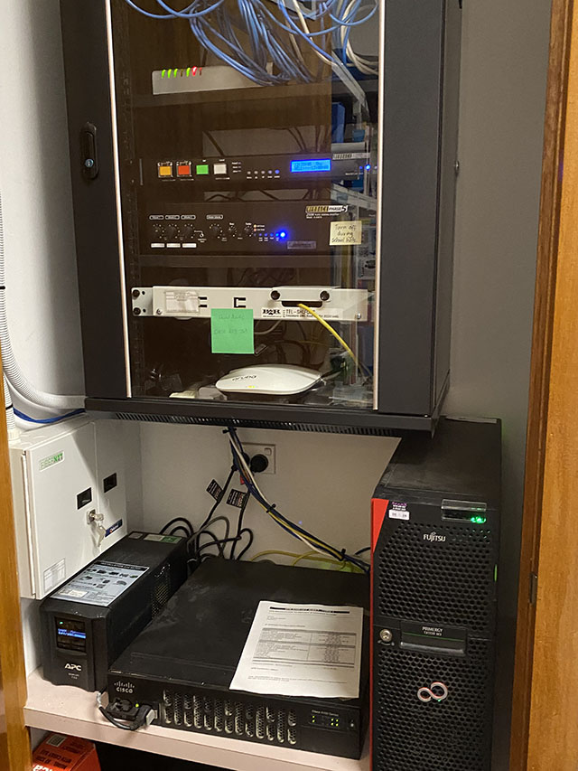 | Situated in resources room adjacent to the library and Community Room
Classroom Switchboard | 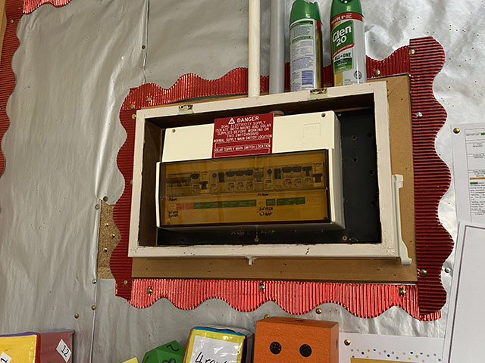 | Flick supply switches to off position
Community Room Switch board | Switch board adjacent to the window  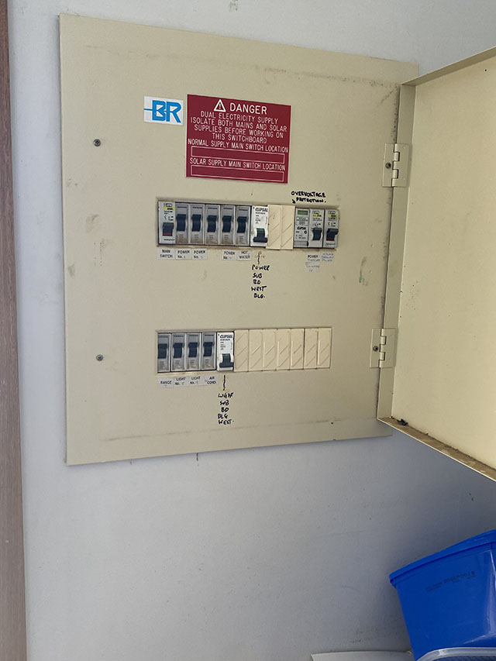 | Flick supply switches to off position
Emergency (Backup) power supply | Solar

First Aid
The school has trained first aid staff at all times. It is preferred that contractors also hold current First Aid Accreditation and is a requirement that they maintain their own task appropriate First Kits on site at all times.
In the event of a workplace injury contractors & their employees are responsible for attending to all minor First Aid. Contractors may request the assistance from the school’s First Aid representatives if treatment is beyond their knowledge of expertise. If serious injuries are sustained, Emergency Services will be immediately contacted.
There is a Defibrillator situated in the Administration Office – accessible to everyone. Staff are trained in the use of the defibrillator.

Restricted Areas/Toilets
Contractors and their employees are invited to use the visitor’s toilet. Contractors and their employees are not permitted to enter or use student toilets or classrooms.
Contractors and their employees must have minimal contact with students at all times. Where work is required, in the presence of students, arrangements must be made to ensure that a member of Staff is present at all times. Contractors & their employees are required to maintain a current WWCC (within 5 years of issue) and provide a copy of this to the school prior to commencing work.

Vehicles and Equipment
The contractor is required to notify the Business Manager/Principal of the vehicles and equipment which will be brought on site. No vehicle is allowed on school grounds without either clearance from the Principal or their nominee or by being accompanied by a member of staff. Cars inside grounds for work purposes are not to be moved unless supervised by an authorised Staff Member.

Work Time Restrictions
Prior to the commencement of work the Principal or Business Manager will inform the contractor and their employees of any work restrictions.
Work in the playground or on sporting ovals must not occur during recess and lunchtime, unless otherwise arranged. Where permitted, appropriate exclusion zones must be established and maintained by the contractor at all times. Mowing and grounds maintenance is to occur outside school hours.

Polices of St Joseph’s Primary School
Contractors are provided with the relevant polices of the school such as:
- DOBCELOHS Policy
- Child Protection Policy
- Asbestos Plan – available from Front Office
Drugs and Alcohol – St Joseph’s Primary School does not permit or tolerate the use or possession of alcohol or illegal drugs on its premises at any time. Contractors & their employees must attend the school site ‘fit for work’ at all times. Contractors & the employees must not attend work under the influence or effects of alcohol, illegal drugs or present for work ‘hungover’.
Any contractor or their employee who attends work in an ‘unfit state’, under the influence or effects of alcohol, illegal drugs or who is deemed to be ‘hungover’ will be stood down and their services terminated.

A contractor or any employee on prescribed medication must ensure that appropriate arrangements are made to guarantee their safety & that of others. Alternative work arrangements must be considered where this prescription medication has the potential to impair their judgement.

Smoking - In accordance with Section 5RB of the Victorian Tobacco Act 1985, smoking is prohibited within the school buildings and grounds at all times. Smoking is also not permitted within 4m of any school entrance. The school displays appropriate signage at all entrances to communicate these restrictions to every person entering the school site. It is the contractor’s responsibility to ensure all workers comply with this legislated workplace arrangement.

Bullying and Harassment
Bullying and Harassment is not tolerated at any time and it is the contractor’s responsibility to ensure that their employees or anyone they engage to undertake work on their behalf acts in a manner that respects the rights of others.

Bullying is:
» Demeaning language or verbal abuse
» Threats, physical or verbal intimidation
» Outbursts of anger or aggression
» Excluding or isolating an individual/s
» “Ganging up” on an individual/s
» Psychological harassment or intimidation
» Giving employees impossible assignments
» Deliberately changing work rosters to inconvenience particular individuals
» Deliberately withholding information that is vital for effective work performance
» Displaying or transmitting sexually offensive messages or materials either by email or hardcopy.

Contractors must advise their employees about unacceptable behaviours and take immediate action to address such occurrences. Employees must also be aware of reporting processes in any instances where they are subjected to any unacceptable behaviour.

Hazards
The Principal or Business Manager are responsible for briefing contractors to any known hazards at the school which may affect their work. Any Hazardous Substances or Dangerous Goods will be indicated to the contractor prior to the commencement of work on the site.

This includes a current Asbestos register which was completed in 2021 (see Asbestos section). Contractors are required to check this report prior to working in these areas.
Contractors are required to report hazards or near misses they come across to the Business Manager.

Asbestos Management
St Joseph’s Primary School maintains an Asbestos Register & Site Plan identifying the location & condition of all asbestos in the Administration Building in accordance with Part 4.4 of the Victorian Occupational Health & Safety Regulation 2017. A copy of this register & site plan will be provided to all contractors & their employees prior to being authorised to conduct work within this area.
Where contractors or their employees discover asbestos containing materials the following measures must be strictly enforced:
- Remove yourself & others from the area immediately
- Contact a member of the Leadership Team immediately
- Do not allow others to enter the area
- Licensed Asbestos Removalists are only permitted to remove asbestos
- Where a worker believes that they have been exposed to asbestos in any way they must seek medical advice.
- 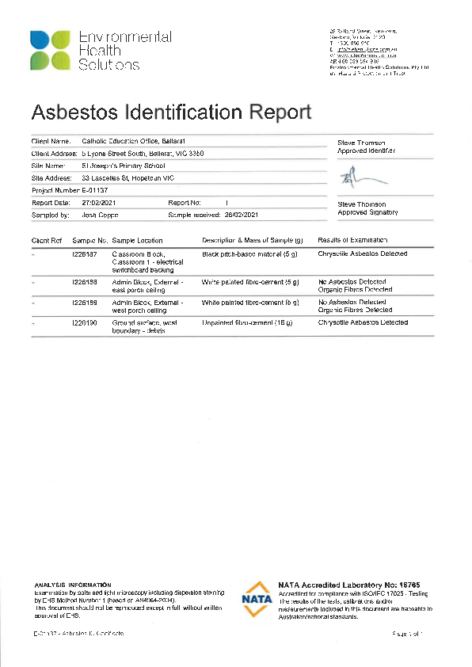

Confined Space Entry
All identified hazards and control measures associated with working in confined spaces must be discussed with the Principal or their nominee prior to being authorised to commence.
In accordance with Part 3.4 of the Victorian Occupational Health & Safety Regulation 2017, where work within a confined space is required, the contractor & any worker entering the area must hold a current Confined Space Entry Accreditation & complete a Confined Space Entry Permit. A copy of both must be provided to the Principal or their nominee prior to commencing work.
When identifying hazards associated with Confined Spaces, consideration needs to be given & control measures implemented for the following:
- The size, location and access to entrances and exits
- The nature of the work and the equipment required
- Harmful atmospheres that may arise such as steam, water, gases
- Electrical hazards that may cause electrocution
- Potential for collapse, entrapment, flooding
- Skin contact with surface contaminants (asbestos)
- Noise
- Extreme temperatures (Heat & Cold Stress)
- Potential of fire & explosions
- Exits are adequate to enable workers to be rescued quickly.

Personal Protective Equipment (PPE)
Personal Protective Equipment (PPE) must be listed in Safe Work Method Statements prepared by the contractor prior to the commencement of work.
PPE may include, but is not limited to;
- Hi Visibility Clothing
- Steel Capped Boots
- Safety Glasses
- Hearing Protection
- Hand Protection
All contractors and their employees must also adhere to St Joseph’s Primary School’s Sunsmart Policy which mandates the use of broad-brimmed hats, long sleeved shirts and the regular application of sunscreen between September and April. No worker is permitted to work on a school site without a shirt on.

Plant & Equipment Safety
All plant & equipment must be operated according to the manufacturer’s instructions and safe operating procedures. This includes ensuring equipment that requires a high-risk licence to operate, only being used or operated by a licensed individual.
All electrical equipment and leads must be inspected, tested & tagged by a suitably qualified individual in accordance with requirements of AS/NZS 3760 In-Service Safety Inspection and Testing of Electrical Equipment.

Worksite Security
Contractors & their employees are responsible for ensuring their immediate work area is secured at all times. The immediate work area must be adequately cordoned off work where necessary to ensure the safety of students, staff and other members of the school community. This may include the use of temporary fencing, parawebbing, bollards & witches hats, or a combination of all.
Danger, Warning signage must be displayed around the defined worksite at all times.

House Keeping
It is important to keep the work area clean and tidy. All contractors & their employees must ensure that waste is disposed of in appropriate containers and that any mess created as a result of the work is contained and cleaned-up immediately.

Completion of Work/s
Upon the completion of all work, contractors & their employees must leave the work area in a tidy manner and remove all equipment and surplus materials.
The Principal or their nominee will inspect works to ensure that the site is left free from hazards and presents no risk of injury to any person who comes in contact with the site.

Incident & Injury Reporting
All incidents, injuries and near misses must be reported to St Joseph’s Primary School’s Principal or their nominee immediately, no matter how minor.
All contractors & their employees are required to assist the School with any subsequent investigation to determine the cause, contributing factors and actions that may be required to improve safety and prevent the likelihood of any recurrence.
An Incident is any unplanned event resulting in, or having a potential for injury, ill health, damage to property or environmental harm.
A Near Miss is a hazard or dangerous occurrence that could have resulted in injury, ill health, loss, damage to property or cause environmental harm, which requires corrective action to prevent any recurrence.
Worksafe must be informed immediately of any notifiable incidents and the incident site preserved in accordance with Section 37, 38 & 39 of the Victorian Occupational Health & Safety Act 2004. Failure to do so will result in the Contractor & their employees being stood down and may result in their services being terminated.

Termination of Services
St Joseph’s Primary School reserves the right to instantly terminate the services of any contractor who fails to comply with requirements of this procedure or through their acts or omissions threatens the Health and Safety of themselves and any other person, or who cause damage to any plant, property or equipment.

Contractor Safety Management Checklist
Minor Works and Maintenanc

The purpose of this checklist is to facilitate the review of the contactor safety management requirements of our school. Where the answer to the question is ‘no’ the Principal should take the required action. All questions must be answered.
To be completed PRIOR to commencement of work.
School: | St Joseph’s primary School, Hopetoun | Job Description:
Contractor: |  | Commencement Date:

ITEM | YES | NO | REQUIRED ACTION | PERSON RESPONSBLE | COMPLETION DATE
- Has the contractor been briefed about known hazards at the school which may affect their work?
- Has the contractor identified the hazards associated with the proposed works from setting up the work area to completion of the job?
- Has the contractor provided the following documentation?  - Current Working With Children Check  - Current Covid 19 Vaccination Certificate  - Safeguarding – Code of Conduct  - Public Liability insurance policy  - Workcover Insurance policy  - Industry licence  - SWMS |  |  | Document Number |  | Current to
- Has the contractor documented control strategies to eliminate or reduce the risks associated with these hazards? (SWMS)
- Have access arrangements been confirmed

- Have appropriate safety/isolation barriers be3en out into place (if required)
- Has the contractor been briefed on the relevant school policies
  - St Joseph’s Child Safety Policy
  - OHS Policy
  - Emergency Management Procedures
  - Asbestos Report (most recent)
  - Critical Incident Policy and procedures.
  - Working in Isolation
  - Drug and Alcohol Policy
  - First Aid and Infection Control policy and procedures.
  - Reporting an accident/near miss
- Has the contractor inducted their employees and subcontractors about the safety plan for this job?
- Has a site-specific induction been provided for the contractor?
- Has the contractor provided the school with Job safety Analysis (JSA) for tasks to be performed addressing issues such as manual handling, fall prevention, PPE, etc?
- Does the contractor agree to provide adequate supervision for their workers (if applicable)
- Does the contractor have processes (ie OHS policy)in place to identify, assess and control site risks (eg noise, dust, fumes, falling objects etc)
- Has the contractor notified the school of vehicles, equipment, and materials to be used on the site?
- Will the contractor secure the vehicles, equipment and materials during and after work?
- Has the contractor provided appropriate signage?(for display if applicable
- Does the contractor have procedures to dispose of waste appropriately and without risk?
- Has the contractor been briefed about Child Safety requirements and provided WWCC for all workers?
- Have the onsite workers signed the school’s Safeguarding Code of Conduct?
- Use all equipment in a safe manner and in accordance with manufacturer’s instructions
- 20.Follow with emergency and evacuation procedures

Conducted by:______________________ Signature:___________________________. Date:

Contractor:_________________________ Signature:____________________________ Date:

School Safeguarding Children and Young people:
School Safeguarding Children and Young People: Code of Conduct

Code of Conduct
As partners with parents in Catholic education and open to God's presence, Catholic Schools pursue fullness of life for all its students and the school community. The schools ensure the care, wellbeing and protection of its students in keeping with the Catholic tradition, which celebrates the sanctity and unique dignity of each person.
Purpose
This Code of Conduct has a specific focus on safeguarding children and young people against sexual, physical, psychological and emotional abuse or neglect. It is intended to complement other professional and/or occupational codes.
All staff, volunteers, external providers and contractors, clergy and school advisory council members of the School are expected to actively contribute to a school culture that respects the dignity of its members and affirms the Gospel values of love, care for others, compassion and justice. They are required to observe child safe principles and expectations for appropriate behaviour towards and in the company of children, as noted below.
Acceptable Behaviours
All staff, volunteers, external providers’ contractors, visitors, clergy and school council members are responsible for supporting the safety of children by:
- adhering to the school’s child safe policy and upholding the school’s statement of commitment to child safety at all times
- taking all reasonable steps to protect children from abuse
- treating everyone in the school community with respect
- listening and responding to the views and concerns of children, particularly if they are telling you that they or another child has been abused or that they are worried about their safety/the safety of another child
- promoting the cultural safety, participation and empowerment of Aboriginal and Torres Strait Islander children (for example, by never questioning an Aboriginal and Torres Strait Islander child’s self-identification)
- promoting the cultural safety, participation and empowerment of children with culturally and/or linguistically diverse backgrounds (for example, by having a zero tolerance of discrimination)
- promoting the safety, participation and empowerment of children with a disability (for example, during personal care activities)
- ensuring as far as practicable that adults are not alone with a child
- reporting any allegations of child abuse to the school’s leadership (or child safety officer if the school has appointed someone to this role)
- understanding and complying with all reporting obligations as they relate to mandatory reporting and reporting under the Crimes Act 1958
- reporting any child safety concerns to the school’s leadership (or child safety officer if the school has appointed someone to this role)
- if an allegation of child abuse is made, ensuring as quickly as possible that the child(ren) are safe
- reporting to the Victorian Institute of Teaching any charges, committals for trial or convictions in relation to a sexual offence by a registered teacher, or certain allegations or concerns about a registered teacher.

Unacceptable behaviours
All staff, volunteers, external providers and contractors, clergy and school council members must not:
- ignore or disregard any suspected or disclosed child abuse
- develop any ‘special’ relationships with children that could be seen as favouritism (for example, the offering of gifts or special treatment for specific children)
- exhibit behaviours with children which may be construed as unnecessarily physical (for example inappropriate sitting on laps)
- put children at risk of abuse (for example, by locking doors)
- initiate unnecessary physical contact which children or do things of a personal nature that a child can do for themselves, such as toileting or changing clothes
- engage in open discussions of a mature or adult nature in the presence of children (for example, personal social activities)
- use inappropriate language in the presence of children
- express personal views on cultures, race or sexuality in the presence of children
- discriminate against any child, including because of age, gender, race, culture, vulnerability, sexuality, ethnicity or disability
- have contact with a child or their family outside of school without the school’s leadership or child safety officer’s (if the school has appointed someone to this role) knowledge and/or consent or the school governing authority’s approval (for example, unauthorised after hours tutoring, private instrumental/other lessons or sport coaching). Accidental contact, such as seeing people in the street, is appropriate.
- have any online contact with a child (including by social media, email, instant messaging etc) or their family (unless necessary eg by providing families with e-newsletters or assisting students with their school work)
- use any personal communication channels/device such as a personal email account
- exchange personal contact details such as phone number, social networking sites or email addresses
- photograph or video a child without the consent of the parent or guardians
- work with children whilst under the influence of alcohol or illegal drugs
- consume alcohol or drugs at school or at school events in the presence of children.

I, ______________________________________________________________________, confirm I have been provided with a copy of the above Code of Conduct.

Signed: ____________________________________ Date: _______________________

